2025



|  |  |
| --- | --- |
| Name | Muhammad Taha Jamal |
| Registration Id | 2112244 |
| Section | BSCS 8th A |
| Course | Introduction to DevOps |
| Instructor | Tariq Khan Ghouri |

**TASK 1:**

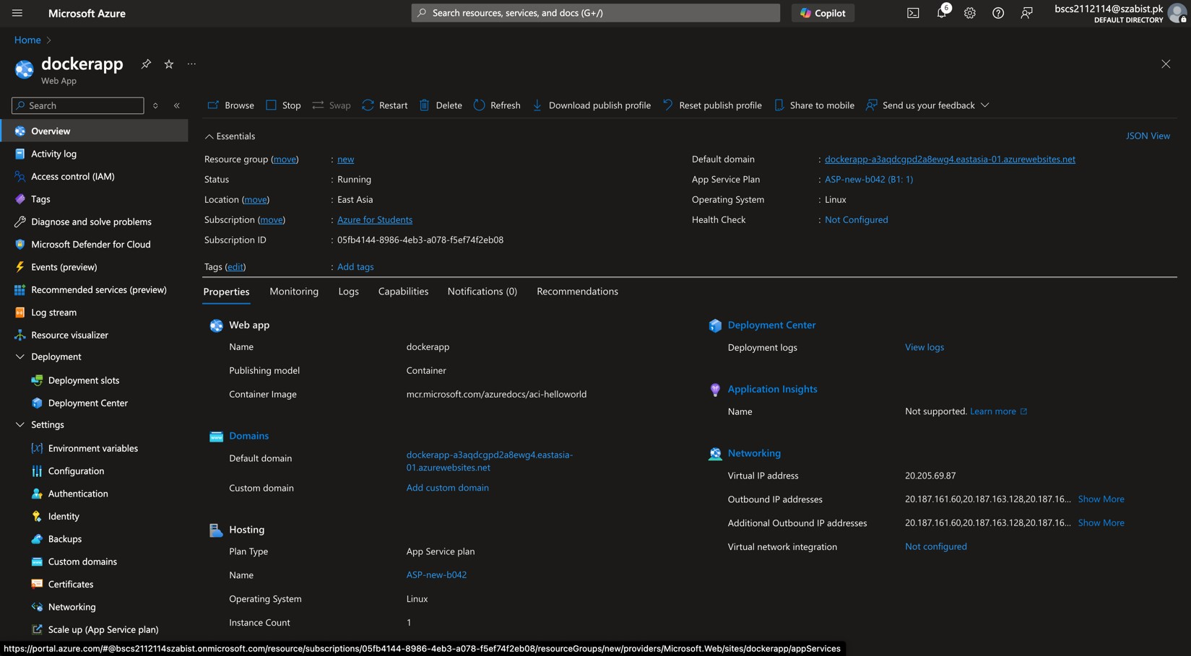

**TASK 2:**

